ASSIGNMENT -6

Implement the program demonstrating use of JSP
Create a database table students_info (stud_id, stud_name, class, division, city) using database like Oracle/MySQL etc. and display (use SQL select query) the table content using JSP.

S/w Requirement: Eclipse editor

Server: Tomcat apache V10 (which is available in Eclipse editor) Xampp server for Mysql and Apache (For Database)
External Jar file : mysql-connector-java-8.0.28 https://dev.mysql.com/downloads/connector/j/ download based on your OS

Step 1.
First, we’ll start Eclipse and switch to the Java EE perspective.
https://www.javatpoint.com/creating-jsp-in-eclipse-ide follow these steps for creating dynamic we project

Step 2:
- Add jar file mysql-connector-java-8.0.28
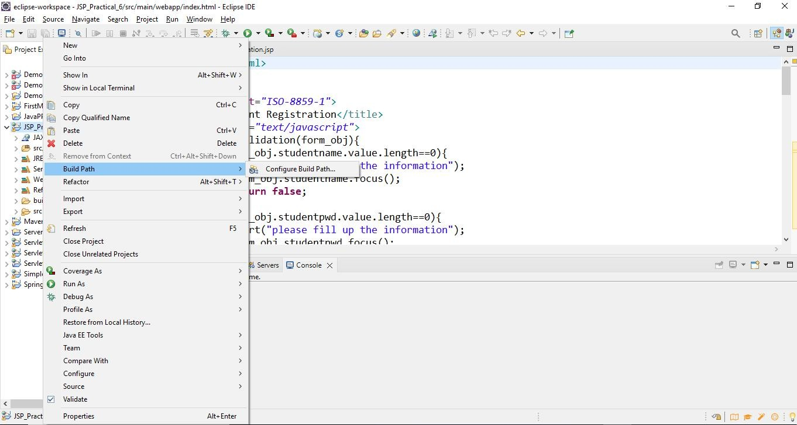
- Right click on project ->build path->configure build path

- Click on classpath (given below)->Add external JARs->browse the path mysql-connector file -> apply -->apply and close

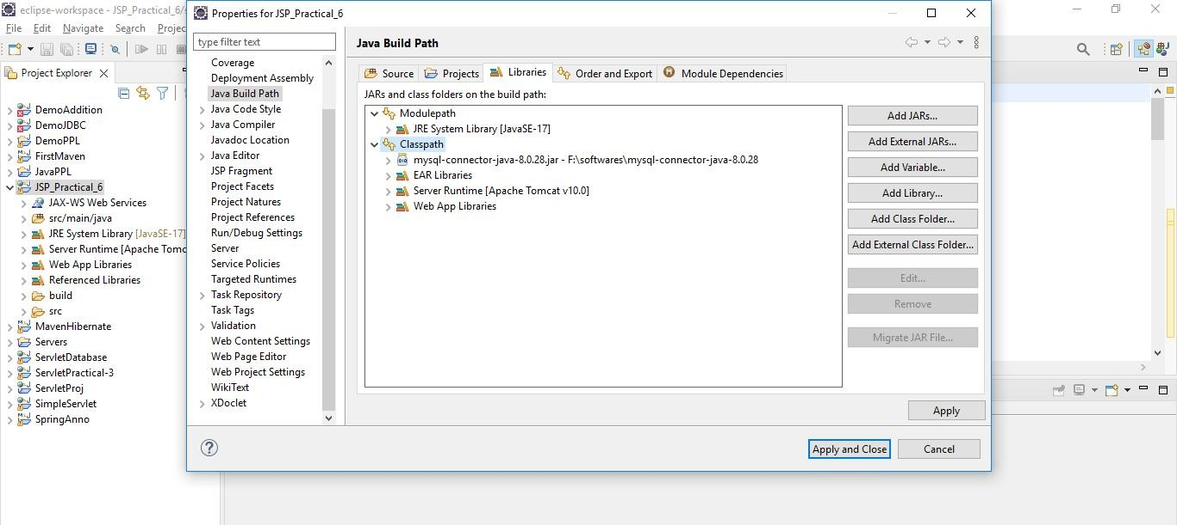

Note: if database connection fails then add mysql connector file in the following path of your project
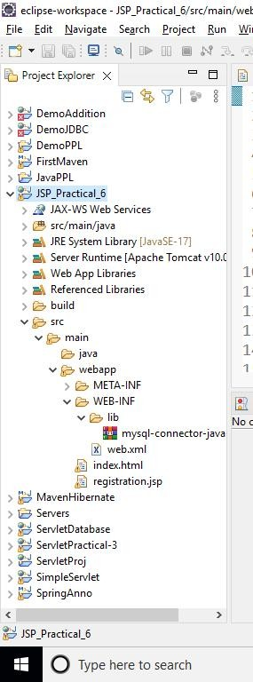

Step 3: create index.html file
<!DOCTYPE html>
<html>
<head>
<meta charset="ISO-8859-1">
<title>Student Registration</title>
<script type="text/javascript"> function validation(form_obj){
if(form_obj.studentname.value.length==0){ alert("please fill up the information"); form_obj.studentname.focus();
return false;

}
if(form_obj.studentpwd.value.length==0){ alert("please fill up the information"); form_obj.studentpwd.focus();
return false;
}
if(form_obj.studentclass.value.length==0){ alert("please fill up the information"); form_obj.studentclass.focus();
return false;
}
if(form_obj.studentdiv.value.length==0){ alert("please fill up the information"); form_obj.studentdiv.focus();
return false;
}
if(form_obj.studentcity.value.length==0){ alert("please fill up the information"); form_obj.studentcity.focus();
return false;
}

}

</script>
</head>
<body>
return true;

<center>
<form action="registration.jsp" method="post" name="entry" onSubmit="return validation(this)">
<input type="hidden" value="list" name="action">
<table border="3" cellpadding="0" cellspacing="0">
<tr>
<td>
<table>
<tr>
<td colspan="2" align="center">
<t2>Student Entry Form</t2></td></tr>
<tr>
<td>Student Name</td>
<td><input name="studentname" type="text" size="50"></td>
</tr>
<tr>
<td>Student password</td>
<td><input name="studentpwd" type="password" size="8"></td>
</tr>
<tr>
<td>Class</td>
<td><input name="studentclass" type="text" size="8"></td>
</tr>
<tr>
<td>Division</td>
<td><input name="studentdiv" type="text" size="8"></td>
</tr>
<tr>
<td>City</td>
<td><input name="studentcity" type="text" size="8"></td>
</tr>
<tr>

<td colspan="2" align="center">
<input type="submit" value="Submit"></td>
</tr>
</table>
</td>
</tr>

</table>
</form>

</center>
</body>
</html>

Step-4 registration .jsp

<%@ page language="java" contentType="text/html; charset=ISO-8859-1" pageEncoding="ISO-8859-1" import="java.sql.*"%>
<%@ page import="java.io.*" %>
<%
Connection con=null; ResultSet rs=null; Statement stmt=null; String uname="root"; String pwd="";

Class.forName("com.mysql.cj.jdbc.Driver").newInstance(); con=DriverManager.getConnection("jdbc:mysql://localhost:3306/registration_db",uname,pwd); out.write("Connected to mysql");
stmt=con.createStatement(); if(request.getParameter("action")!=null){
String studname=request.getParameter("studentname"); String studpassword=request.getParameter("studentpwd"); String studclass=request.getParameter("studentclass"); String studdiv=request.getParameter("studentdiv");
String studcity=request.getParameter("studentcity");
String upstmt=
"insert into
reg_table(name,password,class,division,city)values('"+studname+"','"+studpassword+"','"+studclass+"', '"+studdiv+"','"+studcity+"')";
stmt.executeUpdate(upstmt); rs=stmt.executeQuery("select * from reg_table");
}

%>
<!DOCTYPE html>
<html>
<head>
<meta charset="ISO-8859-1">
<title>Registration</title>

</head>
<body>
<center>

<h2>Student List</h2>
<table border=1 cellspacing="0" cellspadding="0">
<tr>
<td><b>No:</b></td>
<td><b>Name</b></td>
<td><b>Class</b></td>
<td><b>Division</b></td>
<td><b>City</b></td>
</tr>
<%
int num=1; while(rs.next()){

%>
<tr>
<td><%=num %></td>
<td><%=rs.getString("name") %></td>
<td><%=rs.getString("class") %></td>
<td><%=rs.getString("division") %></td>
<td><%=rs.getString("city") %></td>
<%
num++;
}
rs.close();
stmt.close();
con.close();
%>
</table>
</center>
</body>

</html>
Step-5 : Start Xampp Server and Start Apache and MySQL Services
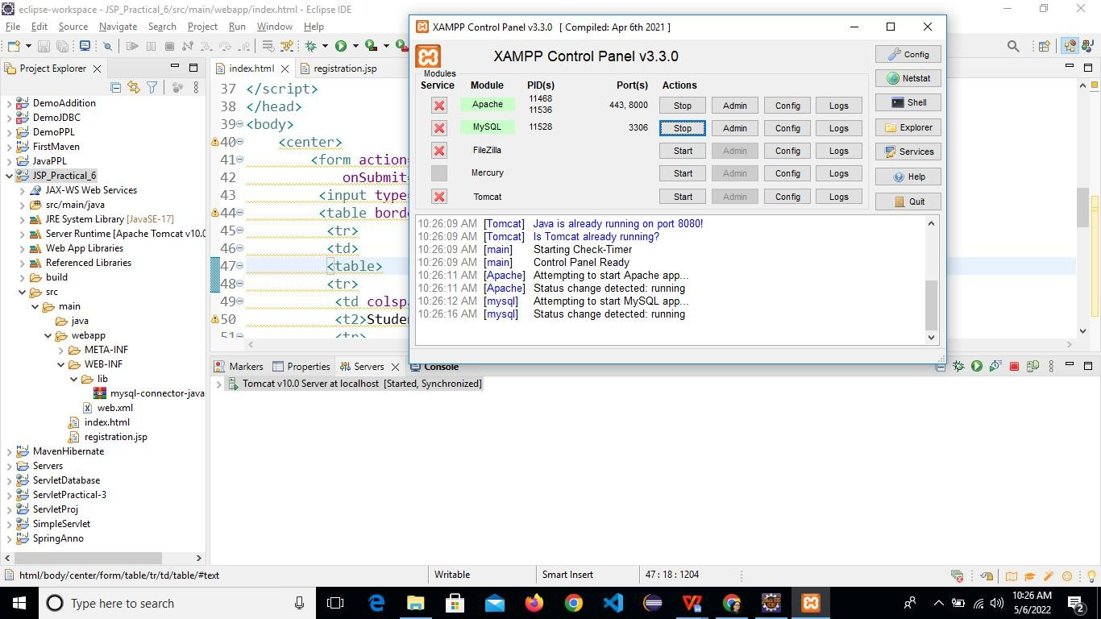

Right click on index.html file ->Run as->Run on server

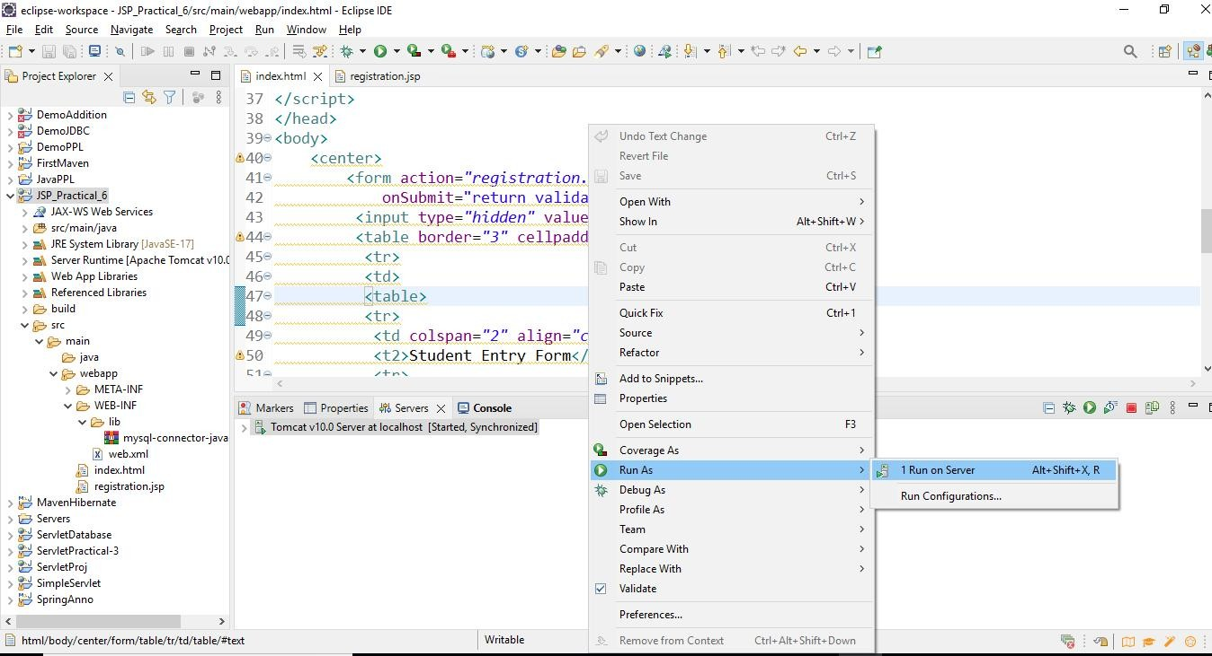
Screenshots of outputs

